World Day of Prayer
Prepared by the WDP Committee of Palestine
March 1st, 2024
“I Beg You… Bear With One Another in Love”
Country Background

- Background

This resource material comes to you from the ecumenical Christian women of the World Day of Prayer Palestine. We worked collectively to inform, pray and act with the rest of the world in 2024, in order to live according to the theme: “I Beg You…Bear With One Another in Love” (Ephesians 4:1-7).

Who among you has not heard of this tiny spot in the Middle East, that for over 3000 years has been significant to three monotheistic religions: Judaism, Christianity, and Islam.

However, the region is much older and has had many names, depending on the many tribes that have settled at different times in the land. The land has been nourished by an unfolding series of civilizations and structures because of its strategic position as a crossroad to three continents: Asia, Africa and Europe.

- History

The region has witnessed the invasion of various powers throughout its history, including the Assyrians (8th century BCE), Babylonians (c. 601 BCE), Persians (539 BCE), Greeks (330s BCE), and Romans (63 BCE). Jesus was born during this era of Roman rule and was crucified by an unholy alliance between political and religious authorities.

In 70 CE, the Second Jewish Temple was destroyed by the Roman Empire. During the 4th century, the Roman emperor Constantine’s mother, Helena, came to Palestine and converted to Christianity. Constantine followed his mother’s conversion, making Christinaity the religion of the Roman Empire. In the 7th century, Muslim rulers conquered Palestine, followed by the Crusaders, the Egyptians and the Mongols. In the 16th century, the Ottoman Empire invaded and ruled the region until the end of World War I.

In the middle of World War I, a letter was sent from Lord Arthur James Balfour (the British foreign secretary) to Lionel Walter Rothschild (a leader of the Anglo-Jewish community). This letter became known as The Balfour Declaration of 1917, and declared the British consent for a national home for the Jews in Palestine. However, the letter clearly stated that the rights of non-Jewish communities in Palestine should be respected.

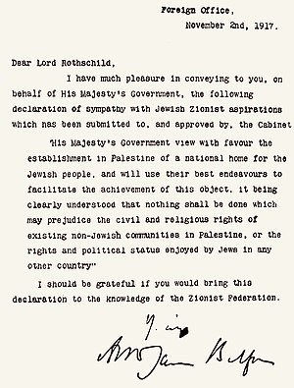

With the end of World War I in 1918, the Ottoman Empire was defeated, and the Middle East was divided between the British and the French. The British Mandate ruled over Palestine and Jordan from 1923-1948. During this period, many European Christians supported the Jewish people in immigrating to Palestine, calling it the “promised land” given to them by God. The British gave land they did not own to a people who had no land, claiming that Palestine was a barren land without people living there. However, Palestine was a rich agricultural region, already the land of “milk and honey,” and a diverse set of tribes were already living there.

Support for the creation of a homeland for the Jews in Palestine increased after the end of World War II, largely because of the Holocaust. When the British announced they were leaving, the United Nations adopted the Partition Plan of 1947, the UN General Assembly adopted Resolution 181, which called for the creation of 2 independent states (Palestine and Israel), as well as a special international status for the city of Jerusalem. Although the UN spoke about two states, until today, no sovereign Palestinian state exists.

On May 15, 1948, the State of Israel was created, a day that is called by Palestinians the Nakba, or the catastrophe. Between 1947 and 1949, at least 750,000 Palestinians were expelled from their homes. Zionist forces took control of 78% of historic Palestine, destroyed 530 villages and cities, and killed around 15,000 Palestinians in a series of mass atrocities, including over 70 massacres.

From 1948-1967, the West Bank and East Jerusalem were put under the rule of Jordan, and Gaza under the rule of Egypt, until another solution was found. Palestinians received a Jordan passport but were not granted full citizenship.

Tensions between Israel and its neighbors escalated, and in June 1967, Israel launched a pre-emptive attack. The impact of this Six-Day War was dramatic, and the effects are still felt today. Palestinians call this war the Naksa, or the “setback.” In only six days, the Israeli military seized the Sinai and the Golan Heights, as well as occupied East Jerusalem, the West Bank and Gaza.
The 4 maps below show the loss of Palestinian land from 1946-2000.

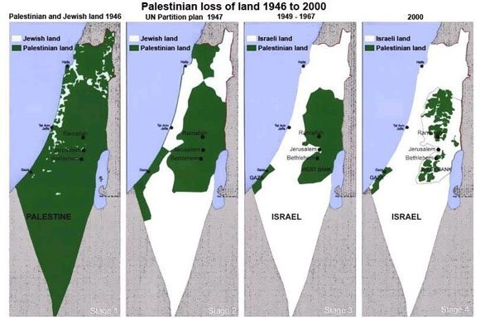

In 1988, Palestine proclaimed its independence only on the land Israel had occupied since 1967. For the sake of peace, Palestinians agreed to live on only 22% of their original land. As of July 31, 2019, 138 of the 193 United Nations member states have recognized Palestine as a state, and the Palestinian flag now flies outside of the United Nations.

- Biblical Sites

When we speak about historic Palestine, we are talking about parts which have become known as the West Bank, Gaza, and Israel. Historic Palestine includes Bethlehem (where Jesus was born), Nazareth (where Jesus spent his childhood), the River Jordan (where Jesus was baptized), and Jerusalem (where Jesus was crucified and rose from the dead). The Mediterranean Sea lies to the west of historic Palestine, where Paul and the apostles traveled on missionary journeys to spread the good news of Jesus the Christ.

- Palestine – Gaza and the West Bank

Gaza:

The Gaza Strip, or simply Gaza, is located on the eastern coast of the Mediterranean Sea, bordering Egypt and Israel. Gaza has been under siege and total isolation by the State of Israel since 2006. The total area of Gaza is 365 square kilometers (141 square miles), with over 2 million inhabitants. This makes Gaza the 3rd most densely populated area in the world. Children make up over 47% of Gaza’s population, making the crisis in Gaza particularly urgent.

In 2005, Israel dismantled their settlements in Gaza and withdrew their military, declaring an end to their occupation of Gaza. However, Israel has continued to control almost all land border crossings, as well as Gaza’s sea and air space. Israel has imposed severe restrictions on the movement of goods and people in and out of Gaza. This has devastated the economy, causing a deep recession that has forced Gazans into inhumane living conditions.

Israel has waged 4 military assaults against Gaza since 2008-9, which has disproportionately harmed Palestinians. During these assaults, approximately 4,000 Palestinians and 100 Israelis were killed. Despite this trauma, Gazans continue to demonstrate that they not only have a strong will to survive, but also for superior education, creative artistic and cultural initiatives, and agricultural efforts.

Although there are less than one thousand Christians in Gaza, there is a strong feeling of ecumenical belonging and service to the whole community. Gazan Christians belong to Orthodox, Roman Catholic and Protestant churches. And, the main hospital in Gaza, al Ahli, is under the supervision of the Anglican Church in the Middle East.

The West Bank:

In 1967, when Israel occupied the Palestinian territories, Western powers called the region the West Bank, because it was on the west bank of the Jordan River. After the Oslo Accords of 1993-1995, the West Bank was divided into Areas A, B and C. The Oslo Accords were intended to be a transitional agreement, not exceeding 5 years. The Palestinian Authority was formed in 1994, and was given partial civil control over Areas A and B. Unfortunately, as a result of the Oslo Accords, Israel maintains control over air, land, borders, and the economy. Today, the Palestinian Authority, based in Ramallah, is the practical capital, with seats of government and parliament buildings.

The map below shows Areas A, B and C. One of the daily challenges that Palestinians face is the restriction of movement on their own land. In order to travel between any of the areas in the West Bank, Palestinians must go through checkpoints. These checkpoints make life incredibly difficult for Palestinians to reach school, work, religious sites, medical appointments, or to visit family. The long lines and wasted hours experienced at the checkpoints is crippling, and causes many Palestinians to lose hope and consider emigrating from the country if possible.

Another aspect of life in the West Bank is the presence of illegal Israeli settlements. There are approximately 250 settlements, with approximately 700,000 Jewish settlers, spread throughout the West Bank, mostly in Area C. A third of the settlements are in East Jerusalem. These settlements are all illegal under international law, as stated in the Fourth Geneva Convention.

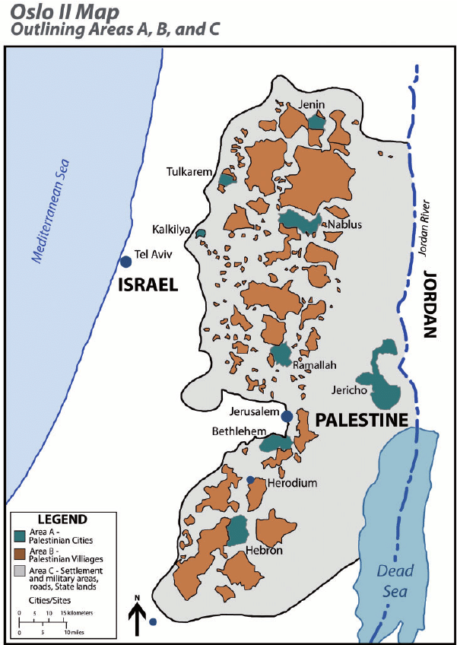

- Population

It is estimated that there are over 5 million Palestinians living today in Palestine and Israel. 2% of these Palestinians are Christian, among a majority of Palestinian Muslims. The total number of Palestinians around the world amounts to over 12 million in countries as far as the United States, Canada, Brazil, Chile and Honduras.

- Christianity

The Church in Palestine is a living church with a special mission and vocation. It is rich in its heritage and pluralistic in traditions. In the land from which Christianity spread and different denominations were formed, one can find all forms of Orthodox, Catholic and Protestant churches.

Jerusalem is the seat of 13 historically recognized churches in the Holy Land and beyond. 75% of Palestinian Christians are from the Greek Orthodox Church. The other churches are: Apostolic Armenian Church, the Roman Catholic (Latin) Church, the Greek Catholic Melkite Church, the Assyrian Orthodox Church, the Assyrian Catholic Church, the Armenian Catholic Church, the Anglican Church, the Lutheran Church, the Coptic Church, the Ethiopian Church, the Franciscan Custodians of the Holy Land, and the Maronite Church. There is also a Baptist, Presbyterian, and United Methodist presence in Palestine.

Christians in Palestine have worked to develop an ecumenical spirit. This ecumenical spirit does not guarantee a complete lack of power struggles amongst some of the churches, but they have carried out the message of the Resurrection of Jesus uninterruptedly for two thousand years. Since the 1980s, there has been a monthly meeting of all heads, or representatives, to discuss common concerns, grievances, and stands to take. In addition, Christians have held joint ecumenical services and have issued occasional statements. The Jerusalem Interchurch Office is a joint project of the churches in Jerusalem, the World Council of Churches (WCC) and the Middle East Council of Churches (MECC). This office helps to coordinate and strengthen ecumenical relationships.

The World Day of Prayer also embodies this ecumenical spirit among women in Palestine. The annual World Day of Prayer worship service is celebrated in a different church every year. The World Day of Prayer National Committee in Palestine collaborates with a variety of church-related organizations, such as the YWCA, the YMCA, Kairos Palestine, Sabeel Ecumenical Liberation Theology, Al Liqa, the Pontifical Mission, Dar el Kalima, Bethlehem Bible College, the Justice and Peace Commission, and Pax Christi International.

Christians in Palestine continually derive courage from a deeply rooted faith. They strive to live the message of Jesus Christ, who proclaimed equality, justice and forgiveness for all.

- Arts and Culture

Arts and culture are crucial for keeping people’s spirits strong and vibrant. Creativity shows that no matter how desperate you are, you can still dance, paint, write, and make music. The arts help people continue living with hope.

Arts and culture also keep Palestinian heritage and memory alive. Poetry, visual art, embroidery, dabkeh (traditional folklore dancing), theater and cinema portray Palestinian life. This affirms that what Palestinians are experiencing is real, whether it is joy or pain. The arts also allow Palestinians to share who they are with people in other countries all around the world.

The arts have also allowed Palestinians to participate in competitions all around the world. Young people have won numerable prizes, giving them a sense of value and purpose.

- Agriculture

Palestinians have tilled, sowed, planted and harvested in the land of milk and honey. They have worked both large and small plots of earth, including gardens and orchards. Herbs, spices, fruits and greens help to feed family and friends. Palestinian women make up a majority of those doing agriculture.

Under the Israeli occupation, many farmers have been denied access to their fields, and olive trees have been uprooted. The olive tree is a symbol of deep roots, longevity, and a sustainable livelihood. For this reason, we used the olive tree as a symbol throughout our worship service. Olives and olive oil have been used throughout the history of our region for medicinal purposes, healthy cooking, and to bless the foreheads of people.

Another plant in Palestine is the cactus, which originally came from Latin America, but which has become an inseparable element of Palestine. Natural hedges and fences were planted to mark houses and neighborhoods. Even after the 1948 destruction of over 400 villages, the cactus lived on to witness the plight of its inhabitants. This cactus, called the “prickly pear” bears delicious fruit.

In some regions of Palestine, one can also find trees bearing almonds, avocados, chestnuts, and citrus fruits, like oranges, grapefruits and pomelos.

- The Role of Women

There is a perception/belief around the world that women in the Middle East region are passive, silent, and non-influential. However, the role of women in Palestine (both historically and in modern times) is active and influential. Palestinian women are steadfast, strong and courageous. They are active in tilling the land. When their husbands are imprisoned or killed, Palestinian women become sole providers, protecting their children and homes.

Many Palestinian women have become prominent figures in society. Some examples are: Dr. Hanan Mikhail Ashrawi (lecturer at Birzeit University, chief peace negotiator and member of Palestinian Government), Dr. Vera Baboun (lecturer at Bethlehem University, first female mayor of Bethlehem), Dr. Khulood Duaybes (ambassador to Germany), Hind Khoury (Minister in charge of Jerusalem Affairs and ambassador to France), Dr. May Kaileh (Minister of Health), Kholoud Faqih (first female Sharia judge in the Middle East). These are just a few examples of prominent women in Palestine. However, all women in Palestine contribute to society, and together they build an open-minded progressive human community.

Although Palestinian women have played an influential role in society, there is still room for better conditions. There must be a greater application of human rights and protection for women, as it states under international law in the 1979 Convention on the Elimination of All Forms of Discrimination against Women (CEDAW). There is a constant need for improvement of Palestinian social and personal laws, as well as an increase in the quota of women participating as decision makers.

An area that still needs further progress for women is in religious institutions. Recently, some Protestant churches have progressed on gender issues, such as ordaining Sally Azar as the first Palestinian female pastor in Palestine.

- Education

Palestinians place a high value on education, with 95.4% of children enrolled in basic education. Education became even more important after Palestinians became refugees in 1948. Palestinians could not take any of their material goods abroad, but with their education, they could find work and educate others.

There are three different systems of education for Palestinians: Israeli, Palestinian, and the UNRWA schools. Within the Israeli and Palestinian systems, there are public and private schools. The private schools are mostly run by religious institutions. Those private schools run by the Christian churches serve children of all faiths in the community. Traditionally, most schools have separated boys and girls, but more recently, schools have become integrated. The schools run by UNRWA are located in the 19 Palestinian refugee camps.

- Health

Health services vary from one area to another in Palestine. In general, hospitals in Palestine are well equipped with professional doctors and nurses. Children in schools are taught cleanliness and basic health and nutritional skills to ensure a healthy mind in a healthy body. Some private hospitals are under church supervision, but they are open to all Palestinians, regardless of faith tradition. This strengthens the relationship between members of the community.

However, the Palestinian health care system suffers from a lack of financial support for administration and running costs. Also, restrictions on movement make it difficult for Palestinians to access health care. It is often difficult for Palestinians to get permits to travel for treatment. There is still quite a lot to do to ensure quality health care for all.

When the COVID-19 pandemic reached Palestine in 2020, the Palestinian government set up curfews and lockdowns, which were respected by all in Palestine. This helped keep the numbers of cases low. When vaccinations became available in Israel, they were not readily available to Palestinians. The female Minister of Health, Dr. May Kaileh, had an extremely difficult task during the COVID-19 pandemic. She did an exemplary job, securing hospital services, obtaining access to vaccinations, and securing medicine and health equipment for Gaza.

- Water

Water is the most crucial issue in Palestine, as well as the Middle East and the whole world. With the climate crisis, water has become scarce, and people are aware of the dangers, especially with the lack of rain. The most important aquifers are in the West Bank in Palestine, but they are located in area C, which is controlled by Israel. Despite the aquifers being located in Palestine, Palestinians have to buy water from Israel! The illegal Israeli settlements in the West Bank and East Jerusalem use four times more water for swimming pools and luxury irrigation.

- The World Day of Prayer in Palestine

The international World Day of Prayer movement reached Palestine in the 1950s. Some of women who brought the movement to Palestine were the wives of clergy of various denominations. They started to pray at the YWCA headquarters, and in Protestant churches in Jerusalem, Ramallah, Nablus and the Bethlehem area.

Aida Haddad, the wife of the first local Lutheran Bishop (Daoud Haddad), got involved. She started by participating as a young reader in worship services, and eventually rose to the position of World Day of Prayer coordinator. In 1993, Aida Haddad was the first Palestinian woman to be elected to serve on the World Day of Prayer Executive Committee. She served two terms from 1993-2003. This representation at the international level continued with the election of Laila Carmi (Roman Catholic), who served from 2003-2013. Then, Nora Carmi (Apostolic Armenian) was elected to the Executive Committee and served from 2013-2022.

Palestine was chosen to write the worship service in 1994, with the theme “Come, See and Act.” Church leaders in Jerusalem were approached by the World Day of Prayer National Committee. In 1991, representatives were appointed from the Roman Catholic, Orthodox, Armenian, Melkite, Lutheran and Anglican churches to form the writing committee. With the help of local and international theologians and consultants, the theme developed into a worship service. Palestinian women with experience in education, and medical and social services helped to write the prayers, calling for “informed prayer and prayerful action.” The worship service caused some controversy because it connected the suffering of Jesus with that of the Palestinian people under occupation. Despite this controversy, the reality of life for Palestinians was highlighted, and the whole world joined Palestine through informed prayer and prayerful action.

Palestine’s involvement with the World Day of Prayer movement has allowed Palestinian women to build bridges with over 100 countries around the world. This has strengthened the Middle East presence and witness. After thirty years, Palestine has been invited once again to write the resource materials for 2024. This invitation comes at a challenging time, when the ongoing injustice has not stopped. It is a time of reflection, self-analysis and living what we believe in. The path is long, but Palestinian women continue to serve as instruments for a better and deeper understanding among the peoples who share this land, trusting and hoping in the humanity of one another.

- Signs of Hope

Despite all the suffering and injustice in the land of the Holy One, Palestinians have maintained their sumud (steadfastness) through mostly nonviolent resistance. There is a genuine effort among Palestinian Christians, Muslims, and some Jews, who believe in equal rights, and who advocate and work for justice. This collaboration involves a witness grounded in each faith tradition, but it also involves a deeper belonging to the land and culture. It is encouraging that there are still some Israelis of different faiths, who refuse being connected with the oppressive state policies, and who refuse to serve in the army. Some examples include The Parents Circle – Families Forum (PCFF) and Jewish Voice for Peace (JVP).

Another sign of hope is the support that Palestinians received when the Palestinian American journalist, Shireen Abu Akleh, was killed. This outpouring of solidarity was encouraging, showing that human beings with moral values care about the future of all the inhabitants of the land, especially the youth who are the future leaders.

We call upon you, sisters and brothers in every part of the world, to bear with us in love. We call upon you to unite your prayers with ours, for a just and peaceful solution that would bring an end to human suffering. We call upon you to stand in solidarity with us to achieve security and peace for all people around the world.

Recommended Sources

Al Jazeera: Palestine, aljazeera.com/where/palestine/.

Burge, Gary. “The Course of Christian Zionism.” Christianity Today, June 26, 2012. https://www.christianitytoday.com/ct/2012/juneweb-only/mainline-christian-zionism.html.

Khoury, Rafiq, and Rainer Zimmer-Winkel, editors. Christian Theology in the Palestinian Context. Berlin: AphorismA, 2019.

Prior, Michael. Zionism and the State of Israel: A Moral Inquiry, 1st Edition. Routledge, 2014.

United Nations Information System on the Question of Palestine (UNISPAL), un.org/unispal/.

Copyright © 2022 World Day of Prayer International Committee, Inc.

“I Beg You… Bear with One Another in Love” was prepared by the World Day of Prayer Committee of Palestine for the worship service and educational activities for the 2024 World Day of Prayer (WDP) annual celebration. WDP materials are developed for the exclusive use of WDP programs organized by national or local committees and their partner organizations. For any other use, materials from the WDP 2024 Resource Packet may not be reproduced without the permission of World Day of Prayer International Committee (WDPIC).

Limited reproduction rights granted—Bible study, Worship Service, Country Background, Children’s Program, Artwork and Artist Statement, WDP composed songs and photos may be reproduced—printed or electronically—for WDP activities with congregations and groups, if appropriate credit is given. WDP National/Regional Committees are permitted to resell reproductions of the resources for the purposes of the WDP program.

Only WDP National/Regional Committees connected with WDPIC can make the resource packet or sections of the materials available online. Committees that make materials available online must ensure groups and individuals who access the online materials are accountable to the committee.

The songs suggested for the worship service and children’s program include copyrighted information from the publishers. Permission to reproduce or translate the songs must be obtained from the publishers. WDPIC only gives permission to reproduce or translate the songs that are originally composed for WDP programs.

Any offerings or funds collected related to WDP activities must be reported to WDP committees.

Scripture quotations are from the New Revised Standard Version of the Bible, copyright © 1989 by the Division of Christian Education of the National Council of Churches of Christ in the U.S.A. and are used by permission. All rights reserved.

For further information, please, contact:

World Day of Prayer International Committee
475 Riverside Drive Room 729
New York, NY. 10115. USA
admin@worlddayofprayer.net - http://worlddayofprayer.net

